EXP NO 1:

Create a simple cloud software application for Payroll Processing System using any Cloud Service Provider to demonstrate SaaS include the necessary fields such as Name of the employee, experience in present org, over all experience, basic pay, HRA, DA, TA, net pay, gross pay etc.

DATE:

AIM:

To Create a simple cloud software application for Payroll Processing System using any Cloud Service Provider to demonstrate SaaS.

PROCEDURE:

Step1: Go to zoho.com.

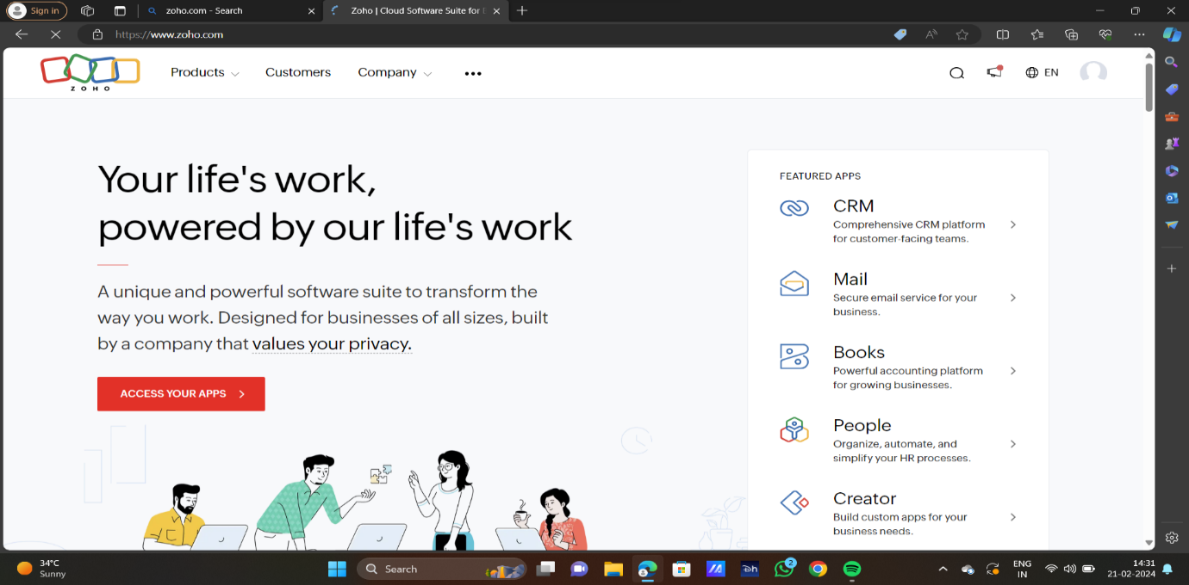

STEP2:LOG INTO THE ZOHO.COM

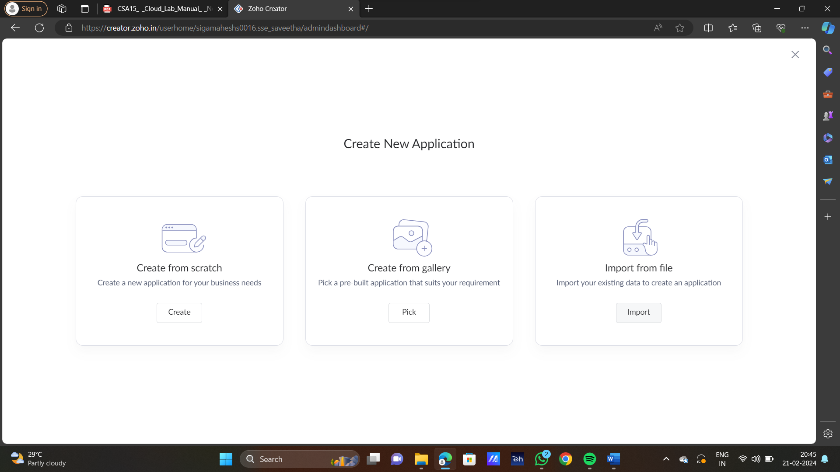

STEP3: SELECT ONE APPLICATION

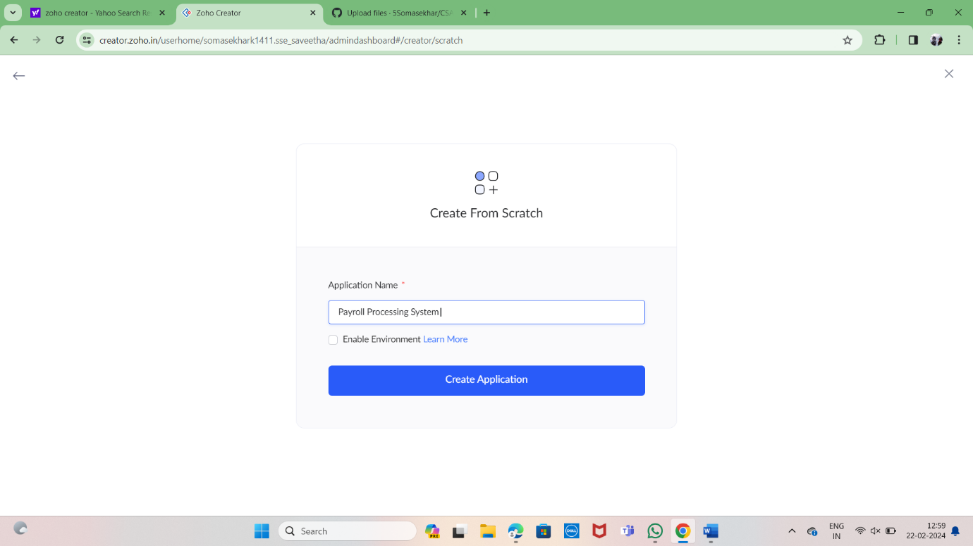

STEP4: ENTER APPLICATION NAME



STEP5: CREATED NEW APPLICATION

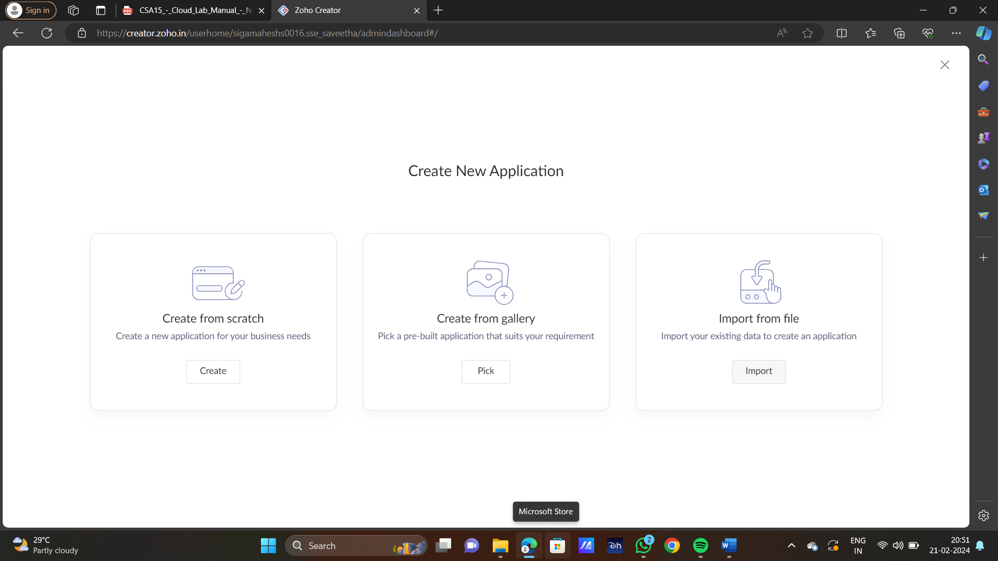

STEP6: SELECT ONE FORM

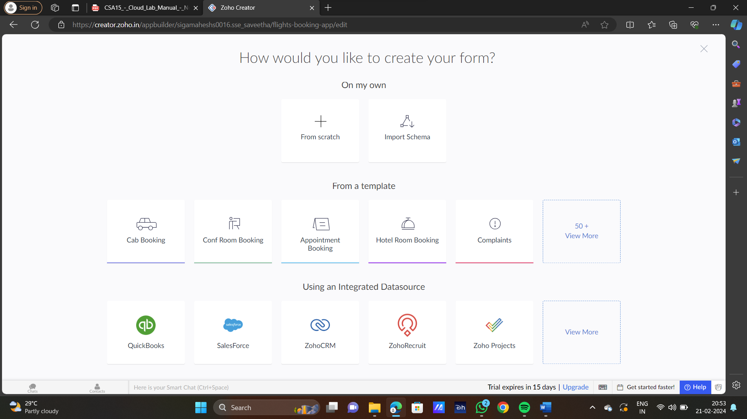

STEP7: THE SOFTWARE HAS BEEN CREATED

